**SCE-ROOM-Project management**

**Team:**

Ilan Kroter 323294843

Noy Nir 207993940

Elad Metodi 206089575

Tom Zaiger 313579526

**Development:**

The web app is stored on the cloud in Github so all the members of the team can contribute to it, we also have a Slack team set up to synchronize the team in important messages.

The project has 3 main folders: src,test and documentation, we want most of the documentation to be in the clubhouse PMI but there will be some parts that will be in word documents.

The src have node.js files in the main directory, but there are subfolders for html and css files that are part of the project.

The test folder will include all the tests we will make for the project.

We will use NPM as our package manager of the project there’s already a package.json file in the github directory with the needed packages for only the linter currently, which we will be using Eslinter.

We will use CircleCI as the CI tool it’s already configured to run basic tests on the code including the linter and also it activates heroku as the deploy part. We disabled the automatic deployment to have more control over the deployment process.

There is a requirement for Unit-Test and feature test checks in the requirement document but we are yet to actually write any javascript code for the project so there’s nothing to test those checks will be added when we will have something to test on.

We selected FireBase as a database for our project, there’s currently nothing there but once we will start using user names, passwords, and housing units. We will need to use this service.

As for name conventions we will be using CamelCase for functions and class names,Snake_case for variables, Spaces around operators(enforced by webstorm as well), tab indentation where needed (Enforced by the linter), constants in UPPERCASE.

**Links:**

FireBase (database): <https://console.firebase.google.com/project/sce-room/overview>

Clubhouse (PMI tool): <https://app.clubhouse.io/sce-project-managment-agile/dashboard>

CircleCI (CI tool): <https://circleci.com/gh/IlanKro>

GitHub (cloud server): <https://github.com/IlanKro/Project-Mangement-SCE>

Heroku (deployment cloud service): <https://sce-site.herokuapp.com/>

Linter: <https://eslint.org/>

Webstorm (IDE): https://www.jetbrains.com/webstorm/

**CH invite link:** <https://app.clubhouse.io/invite-link/5e7b84d1-2bf2-4411-a91a-132209679a39>

**Tools:**

We will be using Circle CI it looks like this:

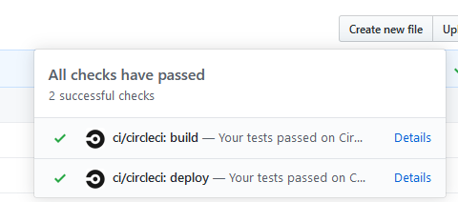

It will build and then deploy the project to Heroku:

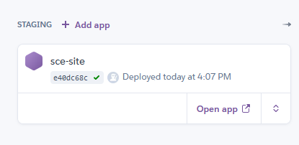

Which currently there is no actual app there because there isn’t anything to upload but the deploying works, its set to deploy src/index.js file currently on the git repository.

We will be using Webstorm from jetbrains as our IDE to program the project.

